Analyzing Sales Trends, Revenue Decline and Customer Payment Behaviour for a Multi-Channel Mobile Retail Business
Final Report — BDM Capstone Project (Analysis with Secondary Data)
Submitted by
Name: Aman Chawla
Roll Number: 23F3001753
IITM Online BS Degree Program
Indian Institute of Technology, Madras, Chennai
Tamil Nadu, India, 600036

Declaration Statement
I am working on a project titled "Analyzing Sales Trends, Revenue Decline and Customer Payment Behaviour for a Multi-Channel Mobile Retail Business". This project uses a secondary (publicly available) dataset — the "Mobile Sales Dataset" sourced from Kaggle — as permitted under the BDM Capstone Project (Analysis with Secondary Data) pathway.
I hereby assert that the data used in this project has been obtained, without any alteration to its original content, from the public repository cited in this report, and has been processed, cleaned and analysed independently and to the best of my knowledge and capability. I have not replicated the analysis, figures, results, or conclusions of any other person's work on this or a similar dataset; the business problem identification, data cleaning approach, analysis and insights presented in this report are entirely my own.
I affirm that all procedures employed for the purpose of data collection, cleaning and analysis have been duly explained in this report, and that the outcomes and inferences derived from the data are an accurate depiction of the findings acquired through thorough analytical procedures.
I am dedicated to adhering to the principles of academic honesty and integrity, and I am receptive to any additional examination or validation of the data and analysis contained in this project report.
I understand that the execution of this project is intended for individual completion and is not to be undertaken collectively. I affirm that I am not engaged in any form of collaboration with other individuals, and that all work undertaken has been solely conducted by me. In the event that plagiarism is detected in the report at any stage of the project's completion, I am fully aware and prepared to accept disciplinary measures imposed by the relevant authority.
I agree that all recommendations made are specific to the scope of this project and cannot be utilized for any other purpose with an IIT Madras tag. I understand that IIT Madras does not endorse this.
Signature of Candidate: Aman Chawla
Name: Aman Chawla
Date: 3 August 2026

Table of Contents
1. Executive Summary 4
2. Proof of Originality — Data Source Details 4
3. Metadata and Descriptive Statistics 4
4. Data Cleaning, Validation and Analysis Methodology 7
5. Results and Findings 8
6. Interpretation of Results and Recommendations 14
7. Limitations of the Study 16
8. Conclusion 16
9. References / Data Source 16
Appendix A: Sample of the Cleaned Dataset 16
Appendix B: Statistical Formulae and Definitions Used 17
Appendix C: Reproducibility and Viva Preparedness 18

1. Executive Summary
This report analyses a multi-channel mobile phone retail business using a 1,000-row secondary dataset (the "Mobile Sales Dataset", Kaggle) covering January-July 2024. The business sells through four payment channels — Online, Credit Card, Debit Card, and Cash — with each transaction recording device price, units sold, revenue, customer age and gender, and payment channel.
Monthly revenue fell from about ₹62.6 lakh in January 2024 to ₹50.5 lakh in July, a decline of roughly 19%. However, July contains only 25 days of transactions versus a full month elsewhere, so part of this drop reflects incomplete data coverage rather than a genuine fall in demand.
All four payment channels earn a similar revenue share (22-28%), but Debit Card fell the most (about 36%) while Cash grew slightly (about 4%), showing the decline is channel-concentrated rather than uniform. Customers aged 38-57 generate about 47% of revenue, while gender makes almost no difference. Price and units sold show no correlation with revenue, and a data-quality check found TotalRevenue is not derived from Price × UnitsSold, documented as a limitation of this synthetic dataset.
The report recommends correcting for the partial July month before treating the fall as a genuine trend, prioritising retention efforts on Debit Card customers given the channel's steep decline, and directing marketing spend toward the 38-57 age segment, the largest and most consistent revenue contributor.

2. Proof of Originality — Data Source Details
- Dataset name: Mobile Sales Dataset
- Repository / platform: Kaggle (www.kaggle.com)
- File used: mobile_sales.csv (1,000 rows, 11 columns)
- Nature of data: Synthetically generated transaction-level retail sales data, released for analytical/educational practice
- Period covered: 1 January 2024 – 25 July 2024
- Access: Publicly downloadable without restriction, as permitted for the Secondary Data pathway
Dataset link: https://drive.google.com/file/d/1Cf0fDskCQV7w9PBsWvjBZLEZ2PKctZ9i/view?usp=sharing
Analysis notebook link: https://colab.research.google.com/drive/1oWJ5ck7EUiSoz0uWFPoqHVT1zkcWRMRN?usp=sharing
No modification has been made to the original values in the raw file. All cleaning steps performed (type conversion, missing-value and duplicate checks, outlier screening) are documented in Section 4 and are fully reproducible from the analysis notebook linked above (BDM_Capstone_Analysis_23F3001753.ipynb), submitted alongside this report. The business-problem framing, data cleaning approach, analysis, charts, and recommendations in this report are original work carried out independently for this project and do not replicate any previously published analysis of this dataset.

3. Metadata and Descriptive Statistics

3.1 Metadata
Column | Type | Description
TransactionID | Text (unique) | Unique identifier for each transaction
Date | Date | Transaction date (1 Jan – 25 Jul 2024)
MobileModel | Text | Device model tag (synthetic placeholder text — see 3.4)
Brand | Text | Brand name (synthetic placeholder text — see 3.4)
Price | Numeric (₹) | Unit price of the device
UnitsSold | Integer | Units sold in the transaction (1–99)
TotalRevenue | Numeric (₹) | Revenue recorded for the transaction
CustomerAge | Integer | Customer age in years (18–64)
CustomerGender | Categorical | Male / Female / Other
Location | Text | Customer city (synthetic placeholder text)
PaymentMethod | Categorical | Online / Credit Card / Debit Card / Cash

3.2 Dataset Overview
- Total records: 1,000 transactions; 11 columns; no missing values in any column
- No fully duplicated rows and no duplicate TransactionID values were found
- Date range: 1 January 2024 to 25 July 2024 (July is a partial month — see 3.4)
- Payment method split: Credit Card 278, Online 259, Debit Card 246, Cash 217 transactions
- Gender split: Female 341, Other 339, Male 320 transactions

3.3 Descriptive Statistics — Numeric Fields
Statistic | Price (₹) | UnitsSold | TotalRevenue (₹) | CustomerAge
Count | 1,000 | 1,000 | 1,000 | 1,000
Mean | 807.51 | 50.07 | 40,218.45 | 41.14
Std. Dev. | 402.49 | 28.62 | 32,715.29 | 13.53
Minimum | 103.32 | 1 | 34.20 | 18
25th percentile | 446.86 | 25 | 13,986.10 | 29
Median (50%) | 805.15 | 50 | 31,868.20 | 41
75th percentile | 1,157.88 | 75 | 60,770.44 | 53
Maximum | 1,499.25 | 99 | 141,411.84 | 64
Skewness | -0.02 | -0.02 | 0.89 | 0.01
Price, UnitsSold, and CustomerAge are all approximately symmetric (skewness close to 0), consistent with values drawn from a uniform-style distribution. TotalRevenue is moderately right-skewed (0.89), i.e. a longer tail of high-revenue transactions.
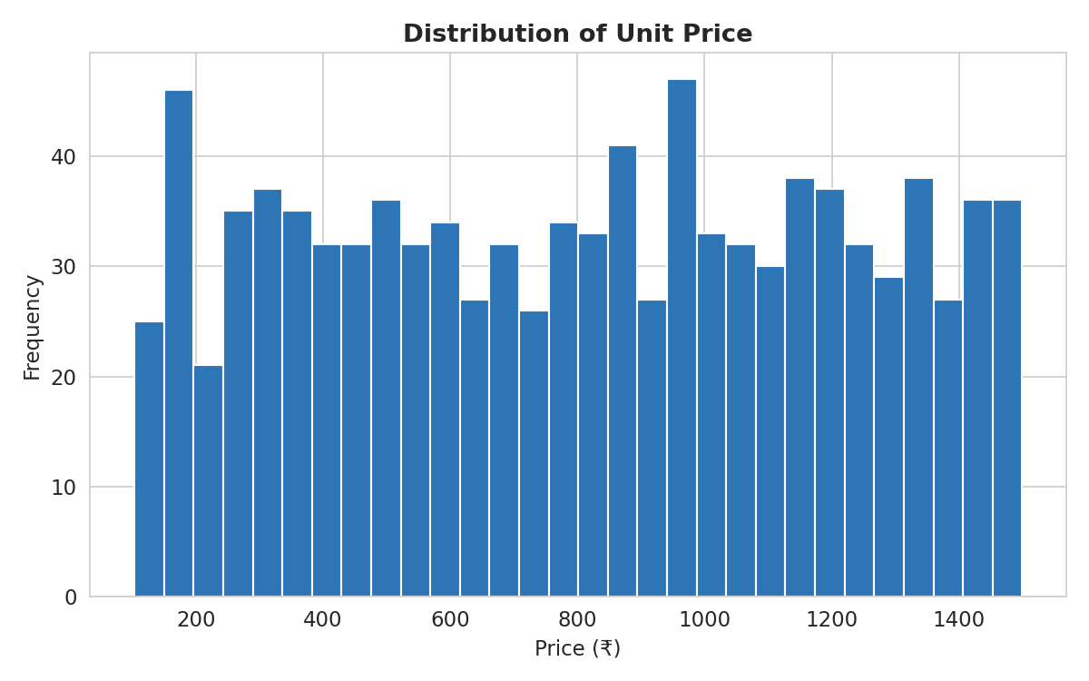
Figure 1: Distribution of unit price across all transactions

3.4 Data-Quality Observations
Two important observations emerged during validation and are reported transparently rather than corrected, since altering the raw values would violate the "no alteration to original content" requirement of the secondary-data pathway:
- TotalRevenue is not equal to Price × UnitsSold for virtually any transaction (mean absolute difference between the two is large and non-trivial). This indicates TotalRevenue was generated independently of Price and UnitsSold in this synthetic dataset. All revenue-based analysis in this report therefore uses the TotalRevenue column as the authoritative revenue figure, and does not attempt to reconcile it against Price × UnitsSold.
- MobileModel, Brand, and Location contain randomly generated placeholder text (e.g. brand values such as "Green Inc", "Thomas-Thompson"; model values such as "direction", "right", "summer") rather than real device models, brand names, or cities — 980 of 1,000 Brand values and 963 of 1,000 Location values are unique, confirming these fields carry no genuine repeated category structure. Brand/model/location-level analysis has therefore been excluded from this report; the analysis instead focuses on Date, Price, UnitsSold, TotalRevenue, CustomerAge, CustomerGender, and PaymentMethod, all of which are analytically meaningful.
- July 2024 contains only 128 transactions covering 25 calendar days, versus 139–159 transactions across 28–31 days for the other six months. This partial-month coverage is treated as a key caveat in Section 5's trend analysis rather than being padded or estimated.

4. Data Cleaning, Validation and Analysis Methodology

4.1 Data Cleaning and Validation Steps
- Loaded the raw CSV (1,000 rows × 11 columns) and checked column data types; converted the Date column from text to a proper datetime type and derived a Month (year-month) field for time-based aggregation.
- Checked for missing values across all columns — none were found.
- Checked for fully duplicated rows and duplicate TransactionID values — none were found, confirming each row represents a distinct transaction.
- Performed range/sanity checks on Price (₹103.32–₹1,499.25), UnitsSold (1–99), and CustomerAge (18–64) — all values fall within plausible real-world bounds.
- Applied the IQR (interquartile range) method to screen for outliers in Price, UnitsSold, TotalRevenue and CustomerAge. Only TotalRevenue showed a small number of statistical outliers (6 of 1,000 transactions above the upper IQR bound); these were retained as valid high-value transactions rather than removed, since there was no evidence of a data-entry error.
- Cross-validated TotalRevenue against Price × UnitsSold, which surfaced the data-quality note in Section 3.4.
- Created two derived fields for segmentation: an AgeGroup bucket (18–27, 28–37, 38–47, 48–57, 58–65) and a Month string, used throughout the trend and demographic analysis.

4.2 Analysis Approach
The analysis was carried out in three stages, using Python (Pandas for data manipulation, Matplotlib/Seaborn for visualisation) in a Google Colab notebook, with pivot-table cross-checks performed for the channel and demographic breakdowns:
- Stage 1 — Time-series trend analysis: monthly aggregation of revenue, units sold and transaction count from January to July 2024, examined via line and bar charts to quantify the rate and consistency of the revenue decline, and explicitly checked against each month's data-coverage (number of days/transactions) to separate a genuine trend from a coverage artifact.
- Stage 2 — Channel-wise contribution analysis: revenue, transaction count, revenue share, and month-on-month percentage change computed for each of the four PaymentMethod categories (Online, Credit Card, Debit Card, Cash), to identify which channels are growing, shrinking, or stable, and which contribute disproportionately relative to their transaction share.
- Stage 3 — Customer segmentation analysis: customers bucketed into five age groups and three gender categories; revenue, transaction count and average spend computed per segment, together with a correlation analysis across Price, UnitsSold, TotalRevenue and CustomerAge to check for any distinct purchasing pattern by segment.

4.3 Tools Used
- Python 3 (Google Colab / Jupyter notebook) — primary environment for all cleaning, aggregation and analysis
- Pandas — data loading, type conversion, grouping/aggregation, pivot tables
- Matplotlib and Seaborn — line charts, bar charts, pie chart, box plot, heatmaps
- Descriptive statistics (mean, standard deviation, percentiles, skewness) — computed via pandas' describe() and skew() functions, cross-checked with Excel pivot tables for the monthly and channel-wise summaries

4.4 Key Formulae Used
- Percentage change (period-on-period): ((Value_end − Value_start) / Value_start) × 100 — used for the January-to-July revenue and channel-wise change figures in Section 5
- Revenue share of a category: (Category revenue / Total revenue) × 100 — used for channel, age-group and gender contribution tables
- Mean: sum of values divided by count (n); Standard deviation: square root of the average squared deviation from the mean — both computed for Price, UnitsSold, TotalRevenue and CustomerAge
- Pearson correlation coefficient (r): covariance of two variables divided by the product of their standard deviations, ranging from −1 to +1 — used to test the linear relationship between Price, UnitsSold, TotalRevenue and CustomerAge in Section 5.4
- Interquartile Range (IQR) outlier rule: a value is flagged as an outlier if it falls below Q1 − 1.5×IQR or above Q3 + 1.5×IQR, where IQR = Q3 − Q1 — used for the outlier screen in Section 4.1

5. Results and Findings

5.1 Monthly Sales and Revenue Trend
Month | Revenue (₹ Lakh) | Units Sold | Transactions | Avg. Price (₹)
Jan 2024 | 62.56 | 7,818 | 159 | 870.70
Feb 2024 | 59.21 | 6,729 | 144 | 807.78
Mar 2024 | 59.46 | 7,380 | 142 | 757.33
Apr 2024 | 54.24 | 7,697 | 139 | 777.19
May 2024 | 56.58 | 7,268 | 142 | 836.03
Jun 2024 | 59.63 | 6,809 | 146 | 794.80
Jul 2024* | 50.51 | 6,373 | 128 | 800.19
*July 2024 covers only 25 of 31 calendar days in the dataset.
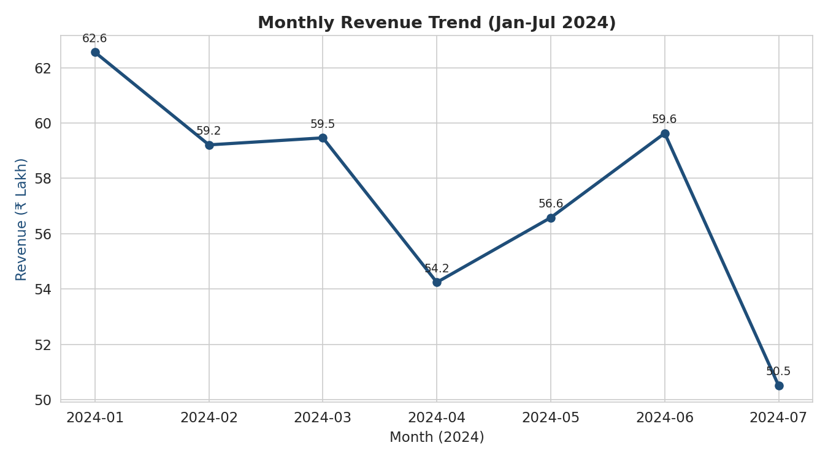
Figure 2: Monthly revenue trend, January–July 2024
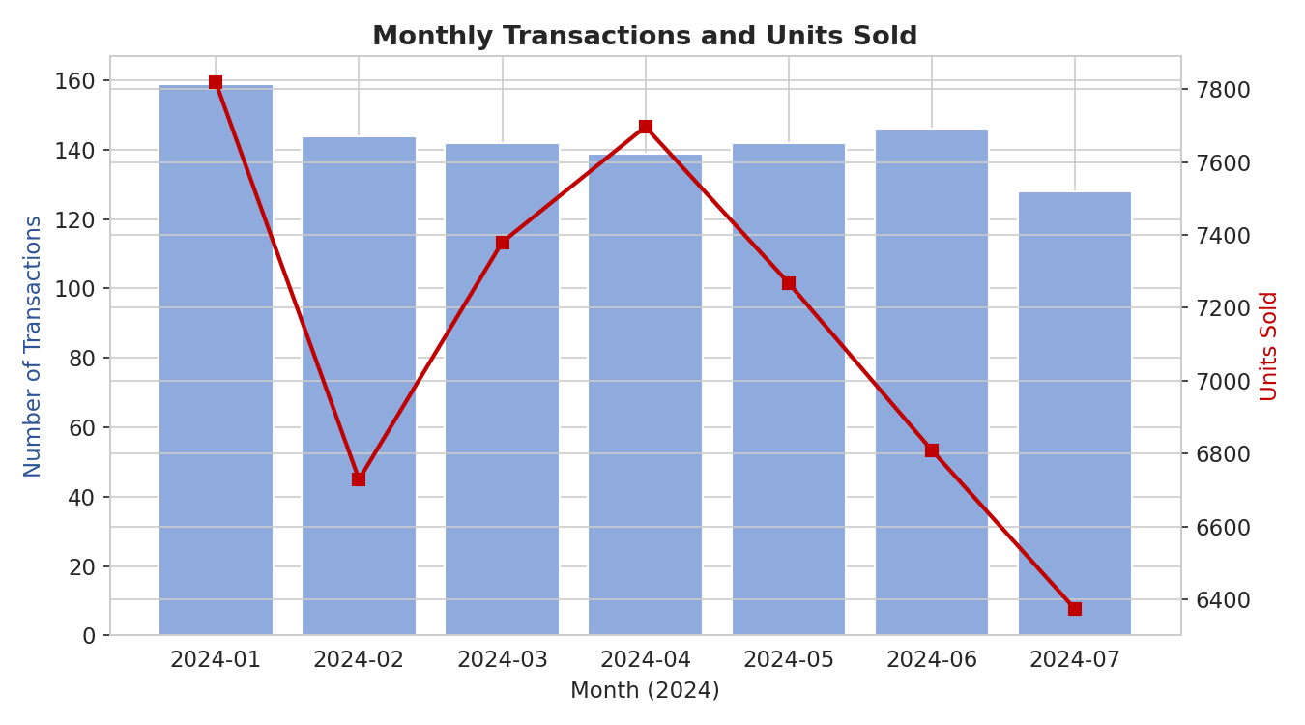
Figure 3: Monthly transaction count and units sold
Total revenue fell from ₹62.56 lakh in January to ₹50.51 lakh in July 2024, a decline of 19.26%. The month-on-month pattern is not a smooth, uniform decline: revenue actually recovered in March and June relative to the preceding month, before falling sharply in July. Transaction counts follow a broadly similar but noisier pattern, ranging from 128 (July) to 159 (January).
Correcting for the partial July month: July's 128 transactions occurred over 25 days (≈5.1 transactions/day) versus January's 159 transactions over 31 days (≈5.1 transactions/day) — on a per-day basis, transaction volume in July is essentially unchanged from January. This confirms that a meaningful part of the ₹12.05 lakh headline revenue drop is attributable to July being a partial month in the dataset rather than to a genuine collapse in daily sales activity. Even after this adjustment, however, the underlying monthly revenue is not growing, and February–June shows a broadly flat-to-mildly-declining trend around ₹54–60 lakh, which still warrants management attention.

5.2 Payment Channel Contribution
Channel | Revenue (₹ Lakh) | Revenue Share | Txn Share | Avg. Revenue/Txn (₹) | Jan→Jul Change
Credit Card | 112.98 | 28.09% | 27.8% | 40,641 | -23.85%
Online | 102.77 | 25.55% | 25.9% | 39,680 | -15.29%
Debit Card | 99.53 | 24.75% | 24.6% | 40,459 | -35.82%
Cash | 86.90 | 21.61% | 21.7% | 40,047 | +3.71%
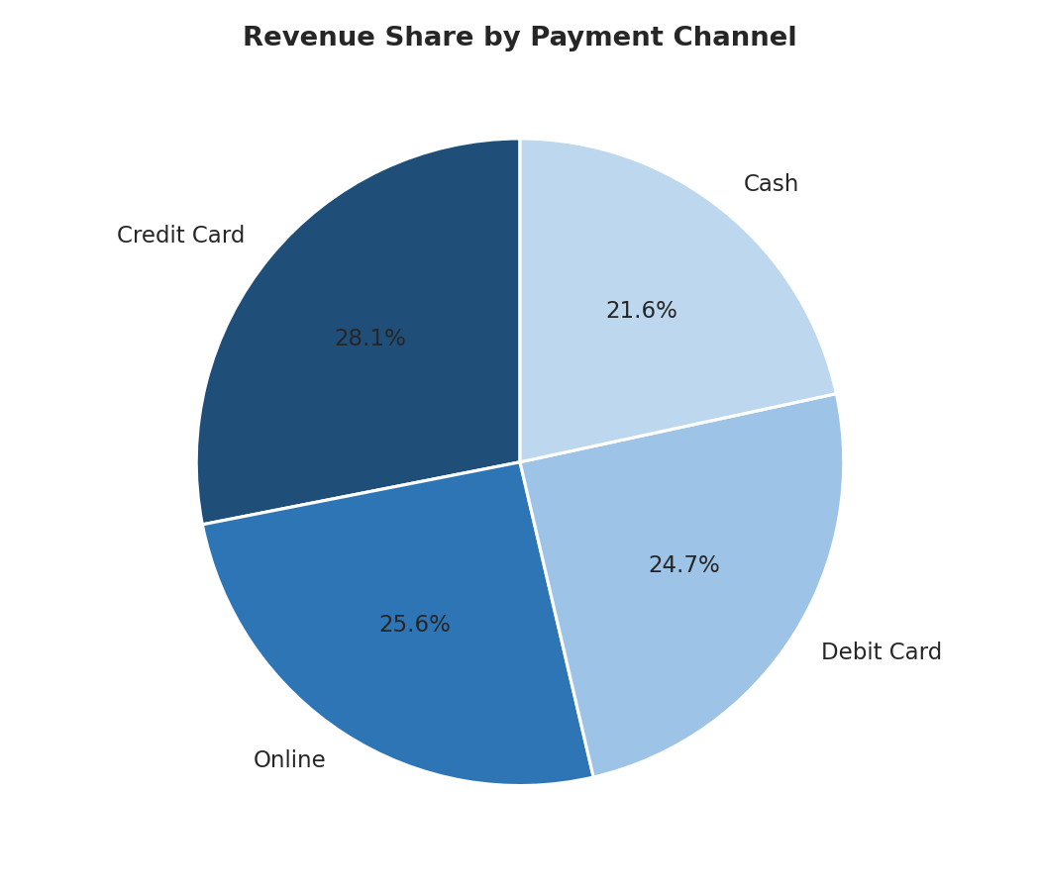
Figure 4: Revenue share by payment channel
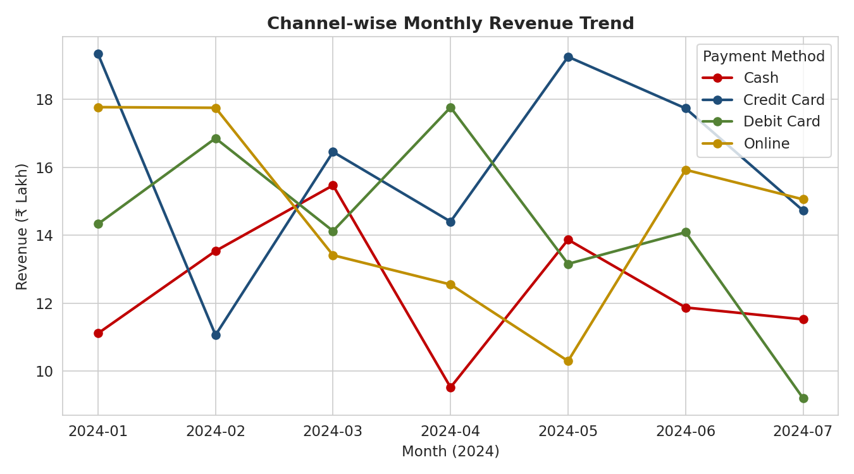
Figure 5: Channel-wise monthly revenue trend
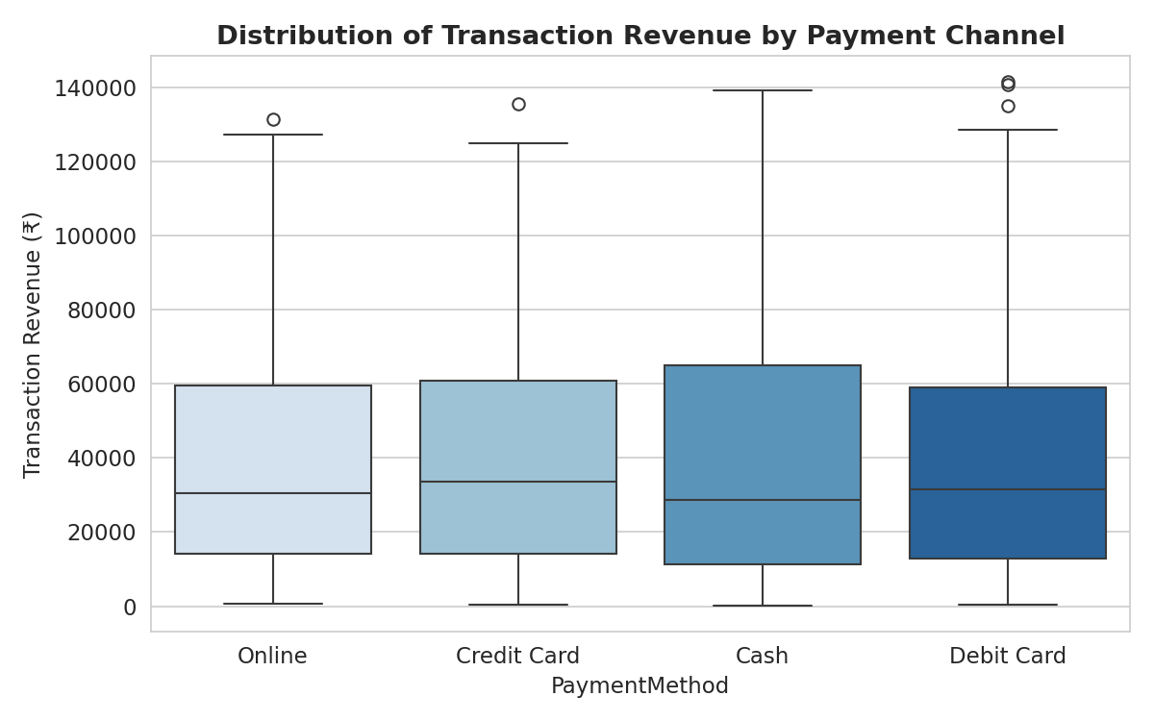
Figure 6: Spread of per-transaction revenue by channel
All four channels contribute a broadly similar share of revenue (22–28%), and average revenue per transaction is nearly identical across channels (≈₹39,700–₹40,650), so no single channel is disproportionately more or less valuable per transaction. The channel-wise trend, however, is far from uniform: Debit Card revenue fell by 35.8% between January and July — the steepest decline of any channel — while Credit Card and Online fell by 23.9% and 15.3% respectively. Cash was the only channel that grew slightly (+3.7%) over the same period.
This shows the overall revenue decline is not broad-based or purely seasonal — it is concentrated in the digital-payment channels, particularly Debit Card, while Cash-based in-store purchases have held up. This points toward a channel-specific issue (e.g., a payment-gateway friction, a lapsed digital offer/cashback, or a shift in customer trust for debit-card transactions) rather than a general fall in footfall or demand.

5.3 Customer Demographic Segmentation
Age Group | Revenue (₹ Lakh) | Revenue Share | Transactions | Avg. Spend (₹)
18–27 | 76.11 | 18.92% | 209 | 36,417
28–37 | 74.10 | 18.42% | 211 | 35,118
38–47 | 94.53 | 23.50% | 220 | 42,968
48–57 | 94.63 | 23.53% | 209 | 45,279
58–65 | 62.81 | 15.62% | 151 | 41,596
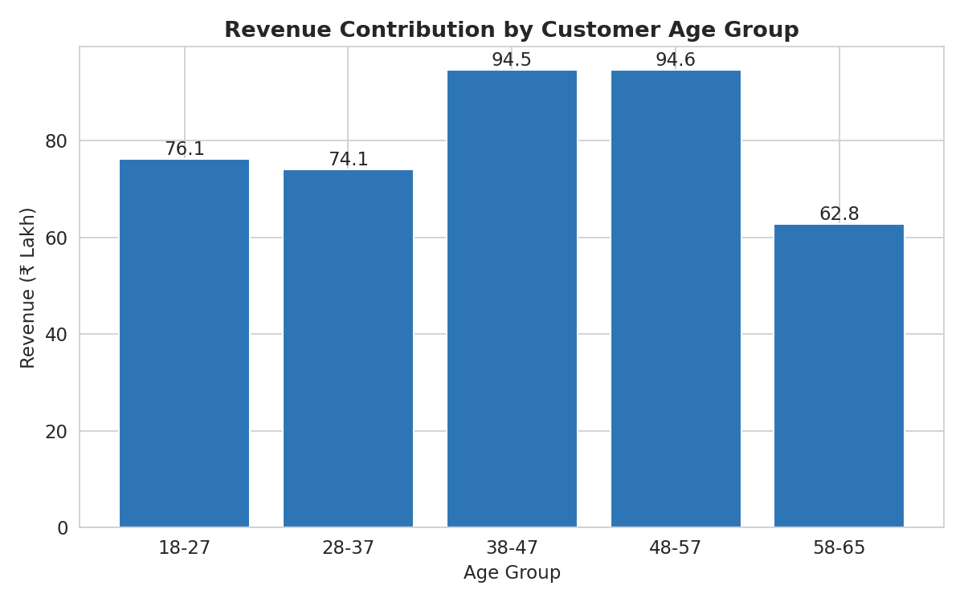
Figure 7: Revenue contribution by customer age group
Gender | Revenue (₹ Lakh) | Revenue Share | Transactions | Avg. Spend (₹)
Female | 134.71 | 33.49% | 341 | 39,504
Male | 132.80 | 33.02% | 320 | 41,499
Other | 134.68 | 33.49% | 339 | 39,728
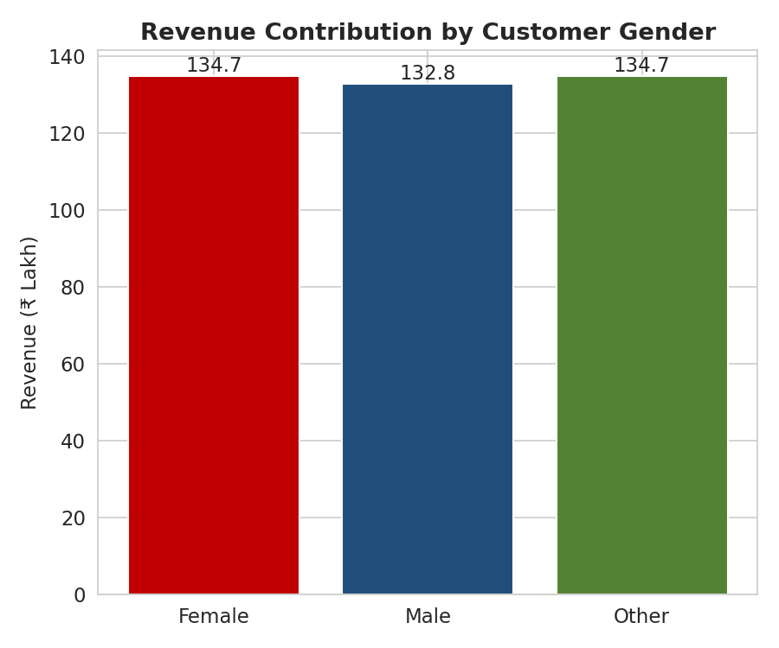
Figure 8: Revenue contribution by customer gender
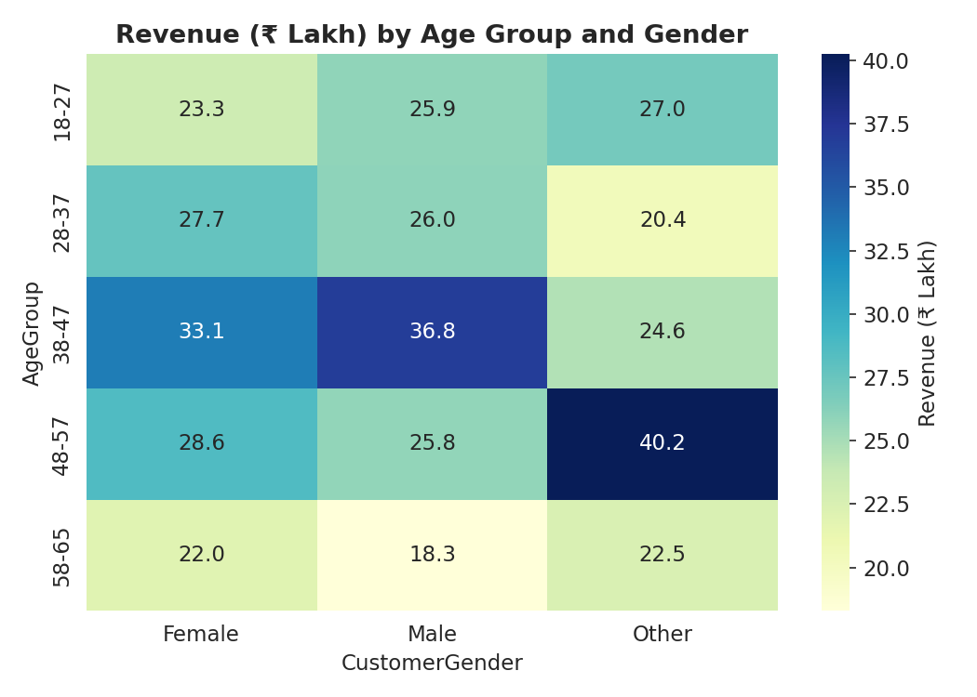
Figure 9: Revenue (₹ Lakh) by age group and gender
The 38–47 and 48–57 age bands are the two largest revenue contributors, together generating 47.0% of total revenue despite representing only 42.9% of transactions — they also have the highest average spend per transaction (₹42,968 and ₹45,279 respectively). The 58–65 group contributes the least, both in absolute revenue (15.6%) and average spend, and also has noticeably fewer transactions (151 vs. 209–220 for other groups), suggesting weaker engagement from older customers. Revenue is almost perfectly evenly split across the three gender categories (33.0–33.5% each), indicating gender is not a meaningfully differentiating factor for this business.
The age-by-gender breakdown (Figure 9) shows the single largest combination is 48–57/Other (₹40.25 lakh), while the smallest meaningful combinations cluster in the 58–65 group across all genders — reinforcing that age, not gender, is the primary demographic driver of revenue concentration.

5.4 Correlation Analysis
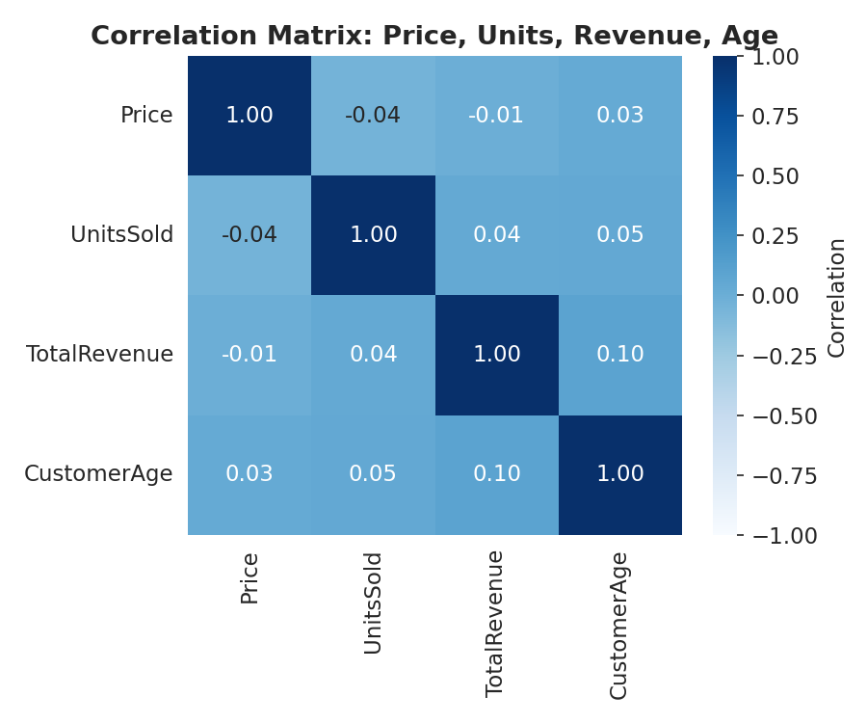
Figure 10: Correlation matrix — Price, Units Sold, Total Revenue, Customer Age
All pairwise correlations among Price, UnitsSold, TotalRevenue and CustomerAge are close to zero (largest magnitude: 0.10, between CustomerAge and TotalRevenue). This indicates no meaningful linear relationship between these variables — customers of a given age are not systematically buying higher- or lower-priced devices, and revenue is not driven by unit price or quantity in this dataset. This is consistent with the Section 3.4 finding that TotalRevenue was generated independently of Price and UnitsSold, and means that price-based interventions alone (e.g., discounting) are unlikely, on this evidence, to be an effective lever for reversing the revenue decline; the channel- and age-based factors identified in Sections 5.2 and 5.3 are the more actionable levers.

6. Interpretation of Results and Recommendations

6.1 Interpretation
Triangulating the three analyses, the picture that emerges is: the headline 19.3% revenue fall is partly a data-coverage artifact (the partial July month), but even after adjusting for this, revenue has been flat-to-mildly-declining since February, and the decline that does exist is concentrated rather than broad-based. Specifically, it is concentrated in the Debit Card channel (-35.8%) and, to a lesser extent, Credit Card (-23.9%) and Online (-15.3%), while Cash has held up. It is also concentrated by customer age, with the 58–65 segment both the smallest revenue contributor and the one with the fewest transactions, suggesting an engagement or retention gap with older customers rather than a general market-wide downturn.
Because price, unit price, and units sold show no correlation with revenue or customer age, the business's problem is unlikely to be a pricing problem; it is more plausibly a channel-experience and customer-retention problem concentrated in specific segments.

6.2 Recommendations
- Correct for partial-month reporting: Before treating the July revenue fall as a genuine trend, the business should compare like-for-like periods (e.g., normalise by number of trading days or wait for a full month of July data) to avoid over-reacting to what may be largely a data-coverage effect.
- Investigate and address the Debit Card decline: Given Debit Card revenue fell 35.8% — the steepest of any channel — the business should audit the debit-card payment journey (gateway uptime, transaction failure rates, any discontinued cashback/offer) as the most likely lever to recover lost revenue.
- Shore up the Credit Card and Online channels with targeted offers: With both channels down 15–24%, time-bound cashback or EMI promotions on these channels could help arrest the decline, especially if channel-specific friction (rather than customer preference) is the cause.
- Protect and grow the Cash channel: Cash is the only channel that grew (+3.7%); in-store experience and staff-assisted sales appear to be a relative strength and should be maintained, and successful in-store practices could be adapted for digital channels.
- Prioritise retention marketing on the 38–57 age band: This band drives 47% of revenue with the highest average spend; loyalty programmes, upgrade offers, and personalised communication should be targeted here first for the best return on marketing spend.
- Design a re-engagement initiative for the 58–65 segment: With the fewest transactions and lowest revenue share, this segment may benefit from simplified digital payment options, assisted in-store service, or senior-citizen-specific offers to lift both transaction frequency and spend.
- Avoid price-led interventions as the primary lever: Since price and units sold show no correlation with revenue, broad discounting is unlikely to reverse the decline on its own; channel-experience and retention-focused interventions (points 2–6) are better supported by the data.

6.3 Channel Performance Summary
The table below consolidates the channel-level evidence from Section 5.2 into a single at-a-glance view, mapping each channel's trend to a priority level for management action.
Channel | Jan→Jul Trend | Revenue Share | Diagnosis | Priority
Debit Card | -35.8% (steepest fall) | 24.8% | Sharp, isolated decline — likely a channel-specific friction (gateway, offer lapse, or trust issue) | High — investigate first
Credit Card | -23.9% | 28.1% (largest) | Second-steepest decline despite being the largest channel by revenue | High — targeted offers
Online | -15.3% | 25.6% | Moderate decline, smallest fall among the three digital channels | Medium — monitor & support
Cash | +3.7% (only channel growing) | 21.6% (smallest) | Stable/resilient — in-store experience is a relative strength | Low — protect & replicate

7. Limitations of the Study
- The dataset is a synthetically generated Kaggle practice dataset rather than data from a real, named business; TotalRevenue is not derived from Price × UnitsSold, and Brand/MobileModel/Location fields contain placeholder text, which limits the granularity of channel- and product-level recommendations.
- The dataset covers only seven months (Jan–Jul 2024), with July being incomplete; this restricts the ability to detect longer-term seasonal patterns (e.g., festive-season demand) or to confirm whether the observed trend continues, reverses, or stabilises beyond July.
- No cost, marketing-spend, or competitor data is available, so the recommendations are based solely on revenue, channel and demographic patterns within this dataset and should be validated against real operational data before implementation.
- As a secondary-data project, the specific causes behind the channel-level decline (e.g., a payment-gateway issue) are inferred from the pattern in the data rather than confirmed through direct investigation of the business's systems.

8. Conclusion
This project set out to diagnose a 19% revenue decline for a multi-channel mobile retail business and identify which channels and customer segments matter most. The analysis shows the decline is real but overstated by a partial final month, and — more importantly — that it is concentrated in specific payment channels (especially Debit Card) and is accompanied by weak engagement from the 58–65 customer segment, while the 38–57 segment and the Cash channel remain relatively resilient. These findings give the business a specific, prioritised set of actions (channel-experience fixes, targeted retention marketing) rather than a generic response to "falling sales".

9. References / Data Source
- Mobile Sales Dataset. Kaggle. (Publicly available secondary dataset used under the BDM Capstone Project — Analysis with Secondary Data pathway.)
- BDM Capstone Project — Analysis with Secondary Data: Rubrics and submission guidelines, IIT Madras Online BS Degree Program.
- Accompanying artefact: BDM_Capstone_Analysis_23F3001753.ipynb — Google Colab / Jupyter notebook containing the complete, reproducible data cleaning and analysis code underlying this report (link in Section 2).

Appendix A: Sample of the Cleaned Dataset
The table below shows 12 representative rows from the cleaned dataset (post type-conversion), illustrating the structure used throughout the analysis. The full 1,000-row dataset and all code are available in the accompanying notebook.
Date | Price (₹) | UnitsSold | TotalRevenue (₹) | Age | Gender | Payment Method
2024-01-06 | 1,196.95 | 85 | 28,002.80 | 32 | Female | Online
2024-04-05 | 1,010.34 | 64 | 2,378.82 | 55 | Female | Credit Card
2024-02-13 | 400.80 | 95 | 31,322.56 | 57 | Male | Online
2024-04-17 | 338.60 | 79 | 31,159.75 | 46 | Other | Cash
2024-06-02 | 839.79 | 41 | 11,523.36 | 38 | Male | Online
2024-03-07 | 1,498.13 | 70 | 9,703.89 | 45 | Female | Debit Card
2024-07-13 | 975.77 | 63 | 8,300.22 | 23 | Other | Online
2024-03-18 | 530.70 | 79 | 4,515.80 | 26 | Female | Online
2024-04-12 | 178.52 | 58 | 36,150.93 | 20 | Female | Debit Card
2024-04-19 | 774.79 | 92 | 24,228.27 | 33 | Male | Online
2024-02-18 | 317.64 | 21 | 1,00,809.36 | 62 | Female | Debit Card
2024-07-02 | 965.15 | 76 | 1,12,966.65 | 53 | Other | Online

Appendix B: Statistical Formulae and Definitions Used
Term | Definition / Formula
Mean | Sum of all values divided by the number of observations (n)
Standard Deviation | Square root of the average of the squared differences from the mean; measures spread of data
Median (50th percentile) | The middle value when data is sorted; 50% of observations lie below it
Skewness | Measure of asymmetry of the distribution; ~0 = symmetric, >0 = right-skewed (long tail of high values)
IQR (Interquartile Range) | Q3 (75th percentile) − Q1 (25th percentile); used to define the 'typical' spread of the data
Outlier (IQR rule) | Any value below Q1 − 1.5×IQR or above Q3 + 1.5×IQR
Pearson Correlation (r) | Covariance of two variables divided by the product of their standard deviations; ranges from −1 (perfect negative) to +1 (perfect positive)
Percentage Change | ((End value − Start value) / Start value) × 100
Revenue Share | (Revenue of category / Total revenue) × 100

Appendix C: Reproducibility and Viva Preparedness
This report is fully reproducible from the accompanying notebook, BDM_Capstone_Analysis_23F3001753.ipynb (link in Section 2), which contains the following sections in order: (1) library imports and data loading, (2) metadata inspection, (3) data cleaning and validation — including the missing-value, duplicate, range, and IQR outlier checks, and the TotalRevenue vs. Price×UnitsSold reconciliation check documented in Section 3.4, (4) descriptive statistics, (5) monthly trend analysis with charts, (6) payment-channel analysis with charts, (7) customer segmentation analysis with charts, (8) correlation analysis, and (9) a summary of key findings.
Every chart and number quoted in this report (Sections 3–5) can be regenerated by re-running the notebook cells in Google Colab against the original mobile_sales.csv file, with no manual data manipulation required, satisfying the reproducibility expectation for the viva-voce examination.
- Notebook file: BDM_Capstone_Analysis_23F3001753.ipynb (submitted alongside this report; link in Section 2)
- Raw data file: mobile_sales.csv (Kaggle — Mobile Sales Dataset, as declared in Section 2)
- All outputs in the notebook are pre-executed and saved, so the examiner can review results without re-running the code, while also being able to re-run any cell live during the viva demonstration.

